 

**MANUAL DOCUMENT VIEWER EMPLOYEE**

1. Introduction 2

2. Login and choose password 2

3. Document viewer 4

## 1. Introduction

Welcome at Salarisbalie. With this manual you will find your way to you online payslips and annual statement on [www.salarisbalie.nmbrs.nl](http://www.salarisbalie.nmbrs.nl). Should you have any questions, please send an e-mail to [info@salarisbalie.nl](mailto:info@salarisbalie.nl) with your name and telephone number en we will contact you as soon as possible.

With the Document viewer you have 24/7 online access the your payslips and annual statements. This saves paper, time and postage stamps.

With login issues you can contact us. For questions about your payslip, the employer is the contact person.

## 2. Login and choose password

For getting access to your payslips you will receive and automatically generated e-mail message to activate your account.

Click on the link to active your account. **You can choose a password and pincode yourselves.** Enter this twice and click on Wachtwoord opslaan/Save password.

***Welcome at Salarisbalie.nl***

*Your employer has outsourced the payroll administration to Salarisbalie.Therefore, you receive a login account. This allows you to have access to your digital documents like payslips and annual statements. For questions about your payslip or e-mail address, the employer is the contact person.*

***Company name***

*Your user name is:*[*xxxxxx@xxxx.nl*](mailto:xxxxxx@xxxx.nl) *(your e--mail address)*

[*Click here to activate your Salarisbalie.nl-account.*](https://salarisbalie.nmbrs.nl/applications/Common/ExternalActions.aspx?view=4&activatekey=50b59dfd5f8046eb929722226d240f6d)

*We trust we have informed you sufficiently  
Kind regards,*

*Salarisbalie B.V.*

*Ronald van der Maarel*[*info@salarisbalie.nl*](mailto:info@salarisbalie.nl)

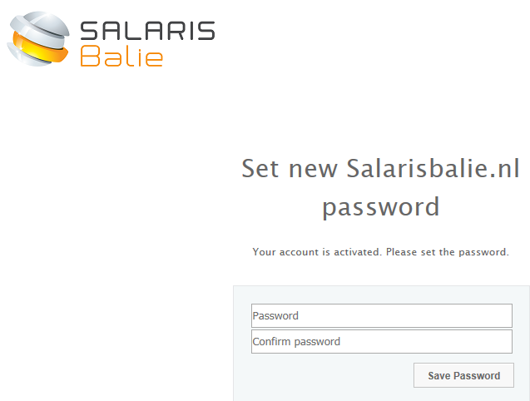

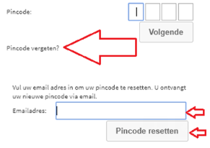

Then you can log in with the received username (e-mail address), password and pin code you have just chosen.

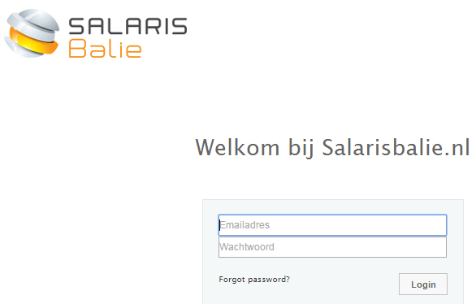

## 3. Document viewer

After you entered the system, you will see an overview of the current year. Here is your payslip available which can be downloaded en printed if you want (but you don’t want to print ☺).

With the button ‘More’ you will find the older years, if processed by Salarisbalie.

With the button ‘Actions’ you can change your password if you want.

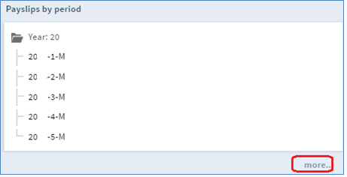

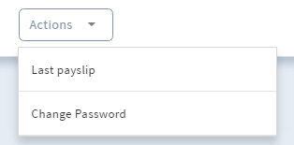

On the interactive payslip your employer might have included a remark or attachment. Of course you won’t see this attachment on a printed version!

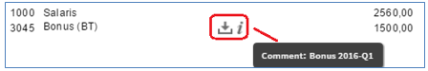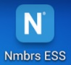**4. Nmbrs® App**

Nmbrs® allows you to see the payslip with the Nmbrs app which can be downloaded in the play store (Nmbrs® ESS). It’s in Dutch. When installed, on the login screen you will fill in:

[*salarisbalie.nmbrs.nl*](http://www.salarisbalie.nmbrs.nl) *(Without www)*

*Your e-mail address*

*Your self chosen password and pin code*

When your employer decided to work with Employee Self Service (ESS), it is also possible to request for leave with the app.

Or enter declarations with the app. It’s very easy!

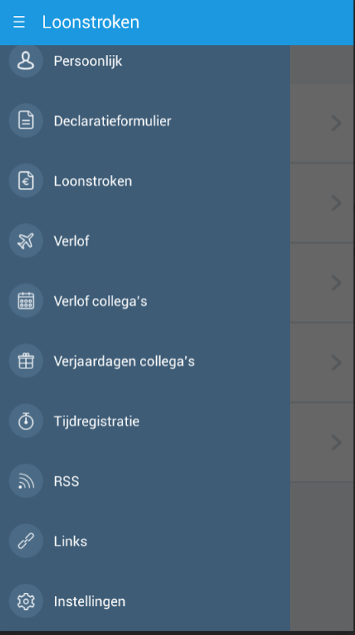

Have fun!